Guide to City Council Meetings
Regular City Council Meetings
Regular meetings of the City Council are held at 5:00 pm every Tuesday, except the last Tuesday of each month.
Special meetings of the City Council may be called by the Mayor or 5 members of the City Council. If a Special Meeting is called, notice is provided to the public stating the time, place, and business to be discussed. Study Sessions or Closed Sessions are considered special meetings and will be noticed 24 hours in advance.

Getting to the City Council Meeting
Parking Structure Address: 332 W Broadway, Long Beach, CA 90802
City Hall Address: 411 W Ocean Blvd, Long Beach, CA 90802
Parking is free for City Council meetings.
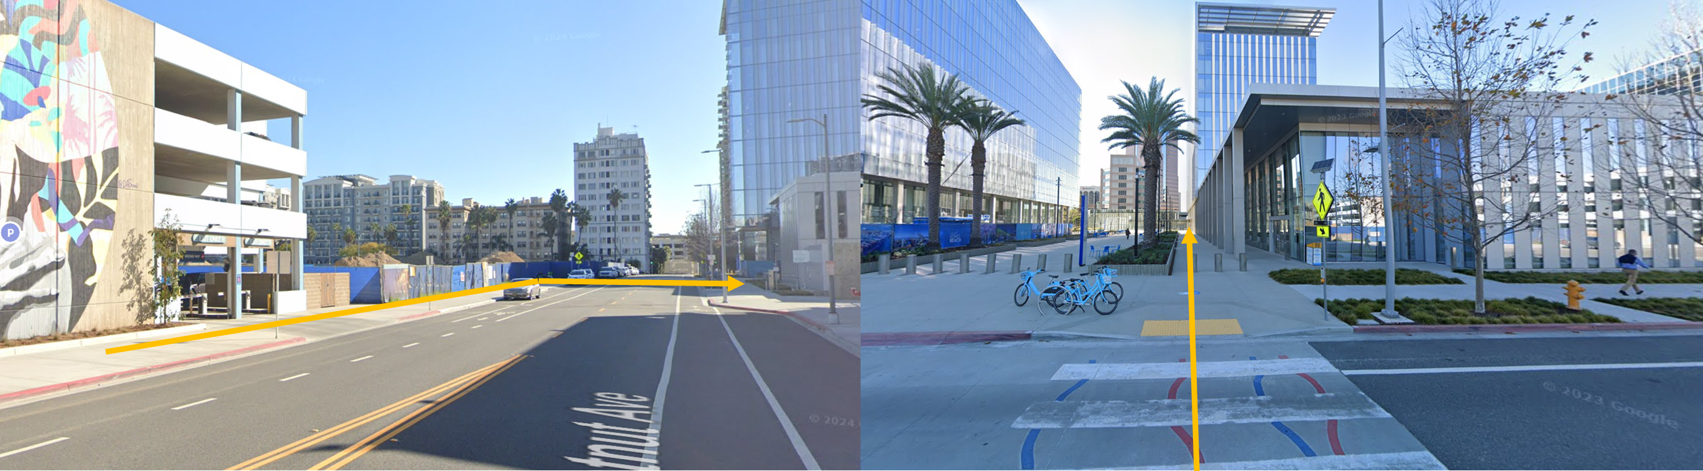

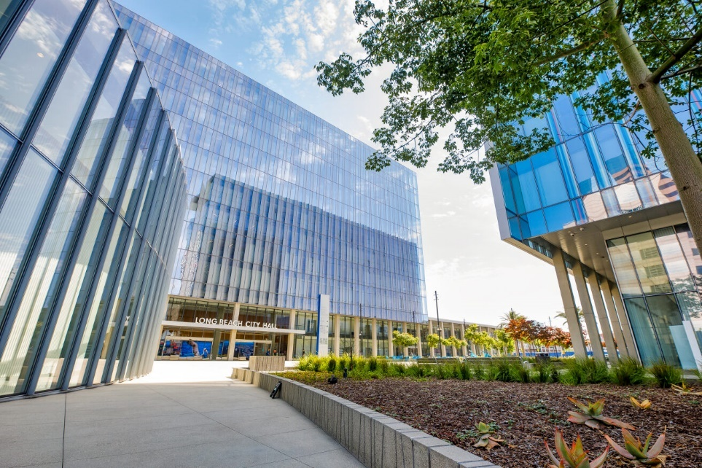
Alternative Modes of Transportation
Taking Public Transportation? Plan your trip to City Hall here.
Riding a bike, skateboard, or scooter? Check out our Interactive Bike Route Map here.
Security Procedures at City Council Meetings
To help the City of Long Beach provide a safe platform, residents attending City Council meetings are required to enter through metal detectors and bags may be searched.
Decorum at City Council Meetings
The City of Long Beach strives to make City Council meetings an inviting place for members of the public to have their voice heard. The City has established rules and guidelines to make sure the City can conduct business while having active public participation. View the ordinance regarding disturbing Council meetings here.
Where to Sit
Members of the public may sit anywhere within the public seating area.
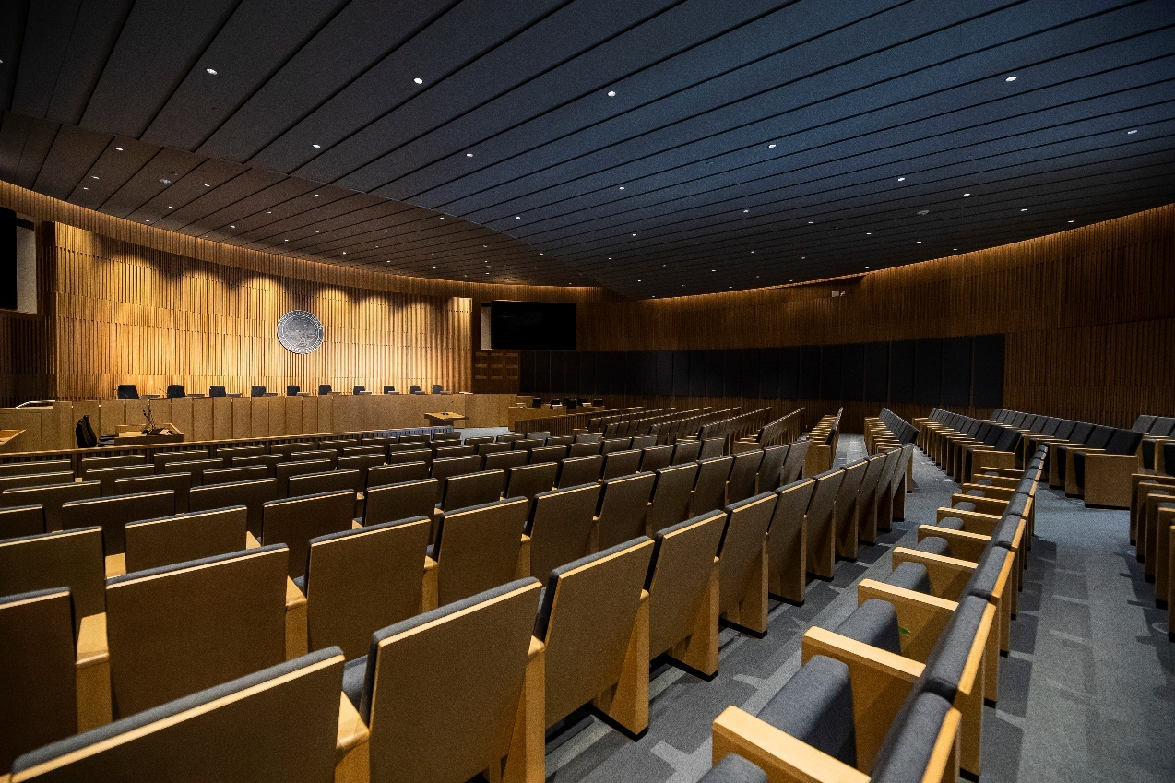

Where is the Agenda and When is it Posted
Agendas for meetings of the City Council, and its Boards, Commissions, and Committees, are posted on the OneMeeting public portal. View the public portal here.

- To view and download agenda item attachments click on the HTML Agenda.

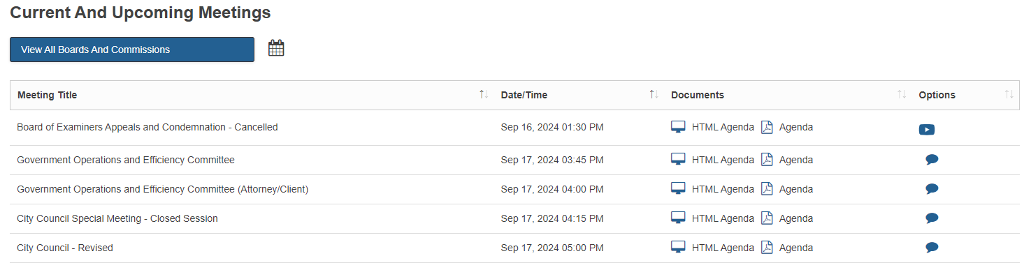

- Click on the item’s recommendation to view the staff report and attachments. You will have the option to view attachments by clicking the eye icon or download the attachment by clicking the cloud icon .
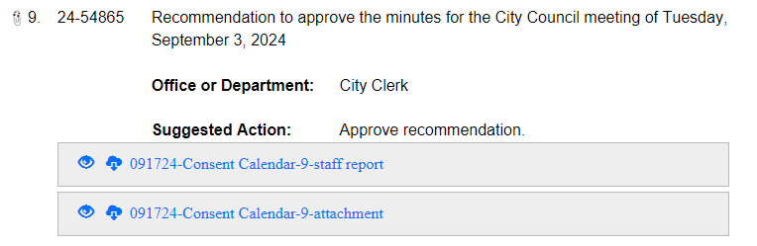
The City Council agenda for regularly scheduled meetings are posted on Monday the week prior to the City Council meeting. This provides time for the Councilmembers and the public to review and research the Council items, engage with neighbors and constituents, and attend the Council meeting prepared to have a discussion.
- On the Friday before the City Council meeting, the City Clerk will post the Supplemental agenda which includes items of urgency that did not meet the Monday submission deadline. For an item to be placed on the Supplemental agenda, three Councilmembers must approve the item as urgent, and the item must include a Statement of Urgency explaining why it should be added. LinkLB is a subscription that will provide an email to you each time the City Council agenda is published. To sign up to receive theses emails you will need to create an account and provide an email address.

Making Public Comment in person at the Council Meeting:
All members of the public are able and encouraged to speak at City Council meetings; however, submitting a speaker card is required. See Order of Business for more information here.
Levine Act
The Mayor, City Council members, and anyone participating in public comment must disclose either verbally or by filling out the Levine Act form of a contribution of more than $500 made to a City Officer within 12 months prior to the date of the proceeding AND if they have a financial interest in the decision of the proceeding during their public comment.
Ex: “I’m disclosing under the Levine Act, that I or the company I represent made a contribution to a City Officer that exceeds the threshold within the last 12 months and have financial interest in this item.”
The key agenda items that trigger the Levine Act include: (1) business, professional, and trade licenses and permits; (2) entitlements for land use; (3) contracts valued over $50,000 (other than competitive bid, labor, or personal employment contracts); and (4) franchises.

Submitting a Speaker Card for Items on the Agenda
Speaker cards can be found outside of the City Council Chambers as you are walking in and at the City Clerk desk inside the Chambers (front left). Speaker cards can be submitted at the City Clerk desk inside the Chambers.
For agenda items, the cutoff time to submit a Speaker Card is once the City Clerk has read the item. There is no limit to how many people can speak. If less than 10 speakers sign up for the item, each speaker will receive 3 minutes to speak. If 10 or more speakers sign up, the time is limited to 90 seconds or less, determined by the Chair.

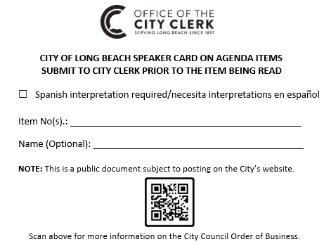
When to go Speak
If you have submitted a Speaker Card to the City Clerk, the Mayor will call your name when it is your turn to queue up during the item’s public comment period.
Items Not on the Agenda “Non Agenda Public Comment”
At any Council meeting, the public may speak about items not on the agenda during the public comment period. There is an opportunity for up to 10 members of the public to speak on non-agenda items at the beginning of the meeting, and the remaining people who want to speak on non-agenda items will have the opportunity to speak at the end of the meeting. Starting 15 minutes prior to the scheduled start of the meeting, the City Clerk will hand out 10 speaker cards for the first 10 speakers and these cards must be submitted before the scheduled start of the meeting. The 10 speakers will get 3 minutes to speak each.
Interpretation Services
Spanish interpretation is available for all City Council meetings.
If oral language interpretation for non-English speaking persons is desired or if a special accommodation is desired pursuant to the Americans with Disabilities Act, please make your request by phone to the Office of the City Clerk at (562) 570-6101, 72 business hours prior to the City Council meeting.
Submitting Written Public Comment for a Council Meeting
The comment period for each regular meeting agenda will begin once the agenda is posted. The comment period will close one hour before the meeting; however, you may still email a comment to the City Clerk via the cityclerk@longbeach.gov address. Although Online Public Comment will be distributed electronically to the City Council at the beginning of the regular Council meeting, or shortly thereafter depending on the volume of comments received, Online Public Comment users should not expect responses to their comments.

Please see the instructions below for submitting Online Public Comment. You may also watch the instructional video here.
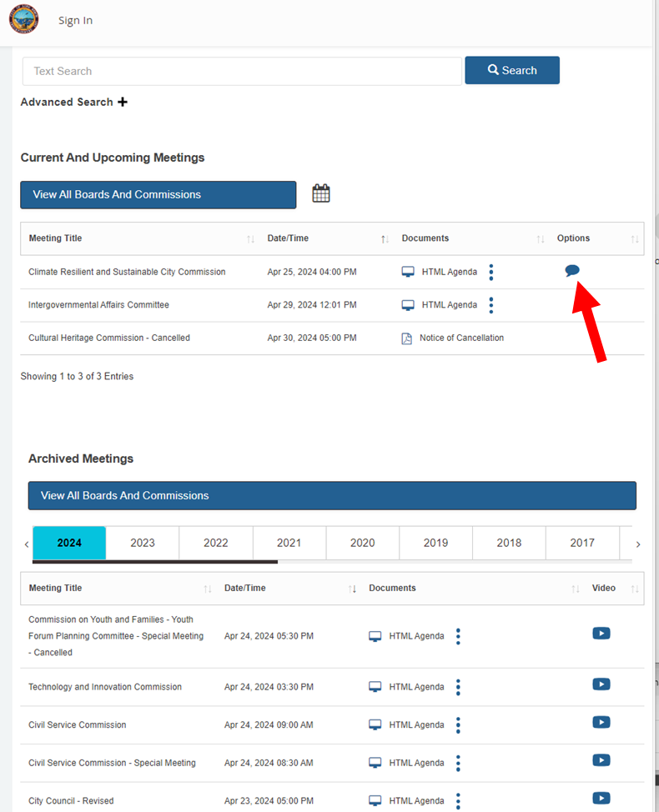
To submit an Online Public Comment, access the City’s OneMeeting portal here and select the “Thought Bubble” for the appropriate meeting.

Select the desired item and follow its instructions to submit the Online Public Comment.
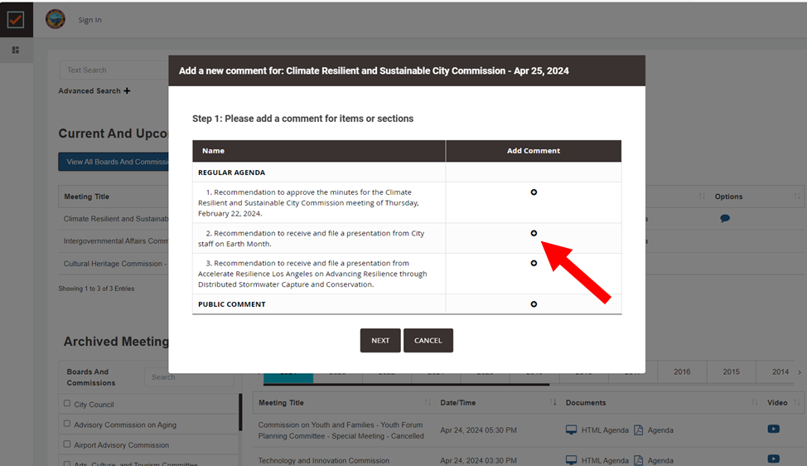
Emailing Written Public Comment for a Council Meeting
Written public comments can be submitted via email to the City Clerk at cityclerk@longbeach.gov. Please include the item number and topic in the subject line of the email.
Watching a Meeting Online
The City Council meetings may be watched online through OneMeeting and YouTube. To watch City Council meetings via OneMeeting, please find the desired meeting and click on the “play” icon (pictured below). The meeting must be currently happening or happened previously for this link to be available.
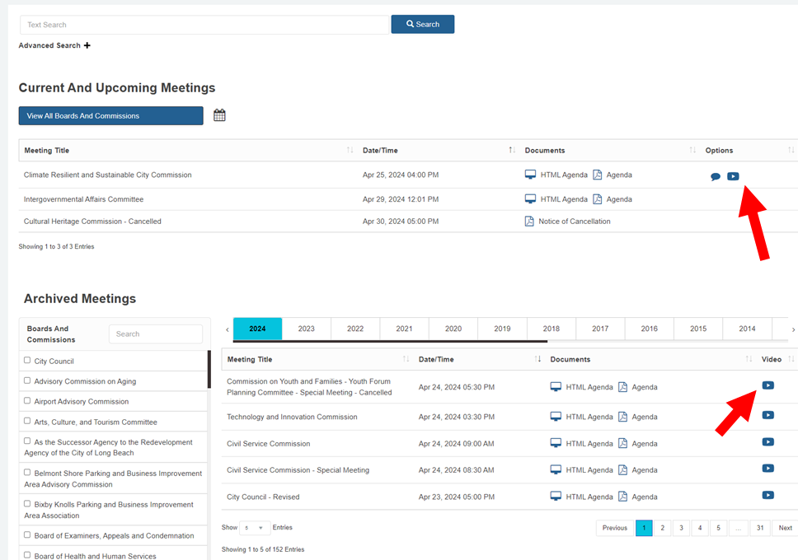

To watch a City Council meeting via YouTube, please visit LBTV’s YouTube channel.

